Jain Avenue, April, 2021

EXISTENTIAL DILEMMA OF JAIN SOCIETY – OPTIONS AND CONSEQUENCES
April, 2021 by Dr. Narendra Bhandari
Can a non-violent miniscule minority survive in the midst of global violence and if so how?
The question we want to debate here is ‘Can a peace-loving, non-violent, miniscule, society survive in a widespread violent global environment, and if it can, for how long? This question has arisen because presently we have an atmosphere of intolerance, violence and some groups of people want to dominate, in thoughts as well as in actions a majority of people all around the world. Violent methods are used for killing animals for food, and entertainment not only with increasingly superior technology, apathy towards biosphere, trees and plants, animals and humans, oceans and atmosphere has intruded every component of our life style, such as fashion, travel and festivities. Violent philosophy has penetrated almost all human activities and continues to grow at an alarming rate- from individual to family to national and international relations, and has replaced peaceful approach without any apparent reason. Terrorism, anarchy, political violence, government violence, police and military violence are on the increase. There is no day when we do not come across shocking news of violence. Is this change natural or deliberate- man made? It is note-worthy that violence is not only limited to environment, birds, and animals, but children, women and people have become most vulnerable.
The belief that most of the people of the world want peace because peace keeps a person’s life safe everywhere, he can use his time for his mental development, material progress and prosperity and spiritual goals have turned into a myth. Statistics show that violence is increasing in the world and the number of violent people and extremist philosophy of monism, is also increasing. Whereas 16 lakh people died due to unnatural causes in 2013 worldwide, the number increased to 18 lakhs in 2019- this includes murders, accidents, and suicides etc. The death of 18 lakh people thus reflects the barbarity of our society, which we call a civil society and it leaves no doubt that our society is becoming uncivilized day by day. There are many people who make sacrifices to remain peaceful, but an ever-increasing number try to increase their political, economic or social power, no matter how many lives are lost in the process and how much harm is done to others.
Is it, then, possible for a peace loving society to survive in such an environment, surrounded by large groups of people, societies or countries, who want to dominate or even rule over others, by expansionism, fear tactics, suicide attacks, etc? Bleed other nations by thousands wounds is a state policy in some countries and scaring followers of other religions, cultures etc, by low key violence, assassinations, etc., have become official declared policies. In such an environment, pleading for non-violence is futile. Far from understanding, no one is even prepared to listen to you. The race to become a super power and spread its faith across the world and abandoning the principle of coexistence is not a sign of a civilized society. The past century has proved that no nation can become a super power by possessing a stockpile of atom bombs. A true super power is the one, which the world follows willingly, voluntarily, without coercion or greed as Buddhism, for spiritual development and enlightenment, from Afghanistan to China, encompassing over half the world, about 2500 years ago.
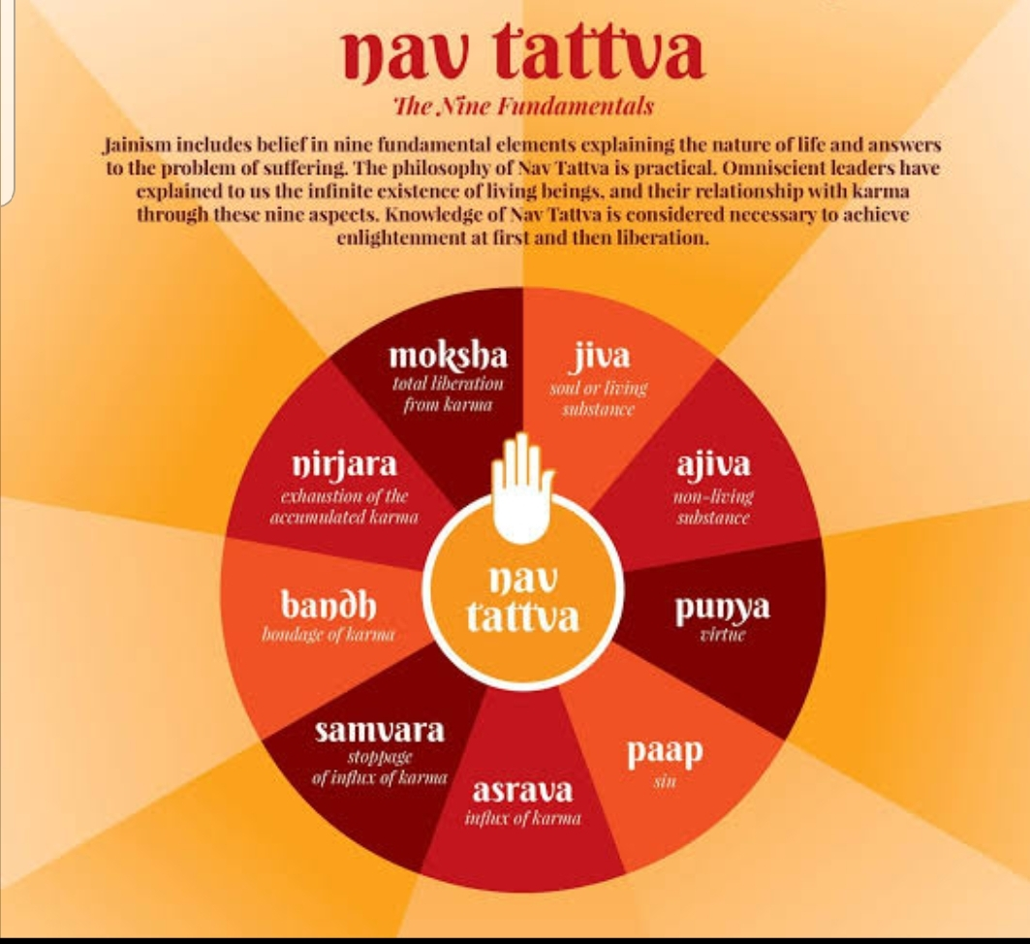
In the present situation, a dilemma exists whether those who are civilized, peace-loving, and compassionate, will survive for a long time, or will such species will become extinct? It has been observed that a handful of socially violent person can frighten the whole society and make it follow their wishes. Refraining to offer any resistance Peace loving people are becoming cowardly in nature, under the pretext of principles of non violence and Anekantavad. Such people will do anything to save their lives, sacrifice their beliefs, cultural values and traditions, change their costumes, their food habits, run away from their country, and many may renounce their religion, and even change their deities. Protecting oneself is the desire of every living being and his duty as well. So finally the question arises whether a non-violent society is able to survive amidst a violent neighbourhood. We must therefore discuss whether our highest duty is to practice non-violence and sacrifice everything else we stand for, including our life? It is said that non-violence is the supreme virtue. This verse is incomplete, and the second half of the verse was forgotten in the zeal of outdoing others as far as non-violence is concerned. The whole verse has its origin in Shanti Parva in Mahabharat, after the terrible war, while expressing the duties of a king, thus :
अहिंसा परमो धर्म​
धर्म हिंसा तथैव चः
The meaning is simple and clear: Non-violence is the ultimate dharma (duty), but for the sake of protecting and survival of one’s dharma (faith), resorting to violence is a still higher duty. In Jainism, non-violence, austerity and abstinence have been considered essential for liberation but later on, non-violence was given much more importance compared to the other two.
Today, Jain society is probably the most non-violent society in the world. Forget about animals, birds and fishes, even eating fruits and certain vegetables, fills a Jain with guilt, the guilt of murder, as if he is committing a terrible sin. Jains do not even appreciate the point that all food is alive and there is no such food which does not involve sacrificing life, be it rice, wheat or plants. Then why does one makes so much effort to save organisms. He himself is a Panchendriya being, with five sense organs and mental faculties. His first duty should be to save himself and his values and philosophy. By ignoring it, the Jain society has become the most cowardly society, and perhaps for this reason their number is decreasing day by day. According to the census, their number is said to be 50 lakhs, which has reduced by about 8 lakhs in the last 10 years. Presently a Jain woman has a fertility rate of 1.1, just about half, as compared to a replacement rate of 2.1. If the rate of fertility remains the same and the number of followers of Jainism decreases at the current pace, then in five or six decades, the number of Jains will become negligible, a lakh or less, worldwide. This simple calculation can be done with the formula of compound interest, that most Jains are familiar with.
Even if we do not worry about the dwindling numbers of Jains or the eventual survival of Jain community, it is the loss of Jain ethos, the irreplaceable, sacred cultural values associated with it, which took thousands of years to evolve, that they have inherited, should worry them. If the traditions that survived throughout the turmoil of history were to disappear in a few decades, it will be a phenomenal loss for the whole humanity. We could have ignored it, if the alternatives were better- but there are many features of the Jain lifestyle, which carry with them a sustainable, enviable, responsibility towards other species, towards the nature, and the earth as a whole. Jain lifestyle is based on Jain philosophy and Jain philosophy is based on the laws of nature. The three, life style (called Charitra or conduct), philosophy (called Darshan) and Laws of nature are indistinguishable.
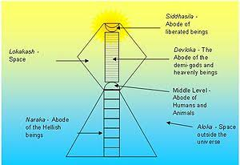
There are many faiths or religions in the world, such as Islam, Christianity, Hinduism, Sikhism, Buddhism, Judaism etc. and each has some good principles. Even then, one can notice a huge difference between Eastern and Western cultures. In the Eastern Hemisphere, which includes India, China, Nepal, Sri Lanka, etc., i.e. the countries in the Asian subcontinent, thinkers observed the nature and the laws governing various processes in nature and developed their philosophy or darshan. From such a philosophy, they adopted a lifestyle, consistent with it. Over the millennia, life style, philosophy and nature became indistinguishable. It took aeons to adopt a life style consistent with nature and this is the way Hinduism and Jainism, the oldest surviving religions known to mankind were formulated. That is why these two faiths are nature friendly. On the other hand, In the West, that is, in the countries of Europe, America, and Africa etc., faiths are relatively young, and faiths and life styles have evolved independent of each other; A life style was first adopted, in absence of faith and then the philosophy and religions were formulated relatively recently, during the last millennium. Religions do have an influence on lifestyle, but it takes a long time for them to unify, amalgamate and become consistent with each other. Therefore, Hinduism, and Jainism (and Buddhism, which is similar to Jainism in many aspects) differ greatly from Islam and Christianity. The need of the hour is to take good aspects of every faith and form one universal faith, acceptable to all and this is possible in this era of knowledge, logic , science exchange of ideas and rapid communication.
Whereas Hinduism is based on the Vedas (books of knowledge), Buddhism is based on the principles realised by Buddha through meditation and Jainism is based on the laws of nature realised by Jain Tirthankaras, again through meditation. These laws include the law of coexistence, law of conservation and law of causality etc. Besides these laws, a few doctrines and practices were also formulated. The three important Jain doctrines are Syadvad, Nayavad, and Anekantavad. These laws and doctrines, make Jainism unique. The beauty about Jain life style, Jain character and Jain society is that , every activity fully reflects its philosophy. Jain life style is the Jain Philosophy. If it is lost, It is difficult, if not impossible, to develop it again and imbibe every minute aspect in the life style.
What are the principles of Jainism? It is clear that the Universe is governed by certain laws and what the primary laws are, has also been elaborated above. The first law , the law of coexistence is embedded in Jain sutra: Parasparopagraho Jeevanam – that is, all living beings are dependent on each other: loss of one organism is equally the loss of all beings and the benefit of one, benefits all others. Principles of non-violence, compassion, forgiveness etc. have been emerged from this law. And its main consequence is one should respect the life of all beings; all life is sacred. Another law is the law of karma according to which every karma (action or thought) has its consequence. Therefore one should live very carefully, knowing very well that he has to face the consequence of every deed in equal measure. The third law is eternalism, according to which a ‘substance’ can neither be destroyed, nor can be created. The essence of everything is immortal, indestructible and eternal, only the form or mode of manifestation continuously changes. To follow these rules is living with nature and to violate these rules is unrighteous.
These principles are together presented under Non-Absolutism or pluralism. The universe consists of only three distinct entities: the Knower (SELF) , the knowable (others viz. other living beings and material things), and the knowledge through which the first two entities interact and modify each other. According to Nayavad, the knowledge gained when a viewer observes an object is limited to only that particular view point with which the knower is observing. It is valid only in that context, and is not complete knowledge, because for a complete knowledge one must integrate the knowledge from all possible points of view, which is impossible. Anekantavada states that the mode (form) of every object changes every moment, so it is not possible to fully know an object with its modes, which may occur through the infinite future. Syadvad enunciates that there are many truths, so no knowledge is absolute or unique. Such deep analysis and insight about nature is not available in any philosophy.
If Jain society disappears then these excellent insights in the working of nature will also be lost with it for ever. It is very difficult to know the workings of nature again.
To complete the argument, it can be stated that organisms with two sensory organs are superior to those with one sensory organ, and similarly organisms with increasing number of sensory organs are progressively more superior. Humans with all the five sensory organs who have a developed mind are the most precious creation of nature, because they can meditate and evolve further, by themselves, and acquire all the knowledge there is. It is very important to save this supreme knowledge attained about nature through supreme meditation.
It is very difficult for some civilized people to survive in the midst of a rude, barbaric and terror- laden society. History is replete with such examples. If we look at the data of the last few thousand years, say since Mahavir and Buddha, it will appear that gentle, civilized, non-violent, and peace-loving societies have shrunk or disappeared from India. This is also true of other countries also like Jews, Red Indians, and in the recent past, people of Iraq etc. and will probably continue to happen in future too.
There have been many Jain kings, army commanders and warriors who fought battles and went to war to save their society and culture, even while they were knowing that they will have to face the consequence of their violent karma. We should not be fooled like Prithviraj Chauhan who defeated and imprisoned Mohammad Ghori 16 times, pardoning him every time and sparing his life, under the pretext of a false pride, forgetting that the prime duty of a king is to protect his citizens. Finally, when Prithviraj Chauhan was defeated, Ghori killed him brutally and with his end, the fate of India and Indians was sealed to remain in centuries of slavery. The Glory of India vanished, and Indian citizens suffered under foreign invasion for ages to come. Our religion was trampled, our culture was destroyed, our dignity could never recover from this one blunder. The lesson is loud and clear: violence has to be dealt with violence otherwise we will be left singing in the praise of a great warrior who lost his life and kingdom to preserve his ego rather than protecting his citizens.
In the present atmosphere, when all the countries are moving towards democratic set up in which numbers count, and societies turning to secularism, where every religion, good or bad has equal rights, sheer number makes Jain society an extremely week component of world. They can neither dominate others, nor make their view point heard. Jains are not able to even defend themselves and their ethos and , in case a need arises. Superimposed over this pathetic situation, is the low fertility rate of Jain women, much below the replacement value. Even if the other groups are friendly, the already thinning number of Jains will approach the extinction levels in the next 5 or six decades, just because of the low reproduction rate.
We thus come to the conclusion that it not possible that a rapidly dwindling, non-violent Jain society (less than 0.07% of the world population), with almost the lowest reproductivity, will last for a long time amidst the largely violent world, nor is it possible that the world at large will, on their own, adopt non-violent and peaceful approach as the guiding principles in the near future in which the Jain ethics ​​and ideals can get the place they deserve.
This leaves only one option before us that we should be able to convince the world through scientific arguments that the path of non-violence is not only the righteous path but it is good for their own well being. Essentially it amounts to proving the Karma theory scientifically, by experiments and by logic. In the modern age, termed as the century of knowledge, such an argument may work and people may get convinced about the superiority of Jain philosophy and ethos.
In order to move forward with this approach, we have to present Jain philosophy to the world properly, strengthened with scientific evidences. Thus study and research become essential to highlight the principles of Jainism. For example, we have to prove with scientific experiments that the principle of karma operates on every living being and everyone is liable to go through the consequences of his good or bad thoughts and deeds. In short term consequences, the history of mankind apparently provides evidence to the contrary but , one has to show that in long run there is no escape from the Karma theory.
Now a days, most people in the world do not believe in the karma theory, simply because If they did, no one would be committing bad deeds towards others. Neither do people at large believe in the occurrence of rebirth of the soul, nor do they believe in interdependence of all living beings. Fortunately the experimental techniques in molecular biology have developed to such a fine extent that we can trace the pathways of karma particles generated in any part of the body to genetic sequence of different cells and also the response of neural network. For people to believe in Karma theory, the consequences of every thought or actions has to be established through scientific experiments. What are the path ways of Ghati (harmful and soul defiling) and Aghati (physiological and social) Karmas, chemical or neurological, how they bind psychologically or physically, how Aghati Karma affect the genome, how Ghati Karma defiles the soul, can be established experimentally in this scientific age, using appropriate tools and techniques. Microbiology and technology have advanced to such an extent that we can trace and study the behaviour and movement of any chemical in the body. One can find out how their transport and communication with various cells takes place in the body, and how the neurons and synapses are stimulated and the way they return to the normal ground state, and what kind of deexcitation energy they emit. It is possible to prove all this through experiments, and it is the right time to do it.
As far as rebirth is concerned, it is an observable fact and cannot be denied because we see millions of cells in the body die every moment and replaced by new ones. Some cells have life cycle of a day, some of a week and some longer, but the fact that they are reborn to serve the body is an undeniable phenomena, for anyone to see. Scientifically, however it has to be established but this can be done only if we assume that there is something like a soul, which controls the activity of every living cell. How else a new cell will replace a dead cell and perform the same function.
Scientific establishing their doctrines is the only choice Jains have, to spread the Gyan given in the Agamas and convince people that they should live by it. If the laws of nature, co-existence, karma, etc., can be established, it is likely that people will have faith in Jain philosophy and a hostile atmosphere may turn into a friendly dialogue. The second approach, of resorting to force for protecting the Jain society is really not an option. The Jain society has to make a choice between these two options to be able to survive and save their cultural and spiritual heritage. Turning their face away from the imminent plight is certainly NOT an option. Only Jain samaj can find a solution to this problem and support academic activity and research in Jainism.

About Author
Dr. Narendra Bhandari
nnbhandari@gmail.com
Dr. Narendra Bhandari, a Space Scientist, professor, author, and editor was amongst the first group of scientists to study the moon samples brought by Apollo missions of NASA and Luna missions of USSR. He was responsible for conceiving and defining the science objectives of Chandrayaan-1. He has won several awards nationally and internationally.
co-edited by Virati Visariya

